Disheng Zheng

dz336

Homework2. Feature Detection

1. Here are the ROC curves of Simple or MOPS descriptors with SSD or Ratio distance. For SSD distance, we see huge improvements on AUC just by using the simple descriptor. The best model performance is MOPS descriptor Ratio distance, which has the AUC of 0.898. Simple ratio has almost the same performance with AUC of 0.897. Since the two pictures have almost no intensity, scale, and rotation change. The simple and MOPS descriptors have similar effects. The ratio test performs a lot better than SSD because the features on the rock have similar patterns, and it is better to find the best matching with ratio distance.

|  |  |
| --- | --- |
| Simple SSD  AUC = 0.886  /Users/disheng/Desktop/simple ssd.png | Simple Ratio  AUC = 0.897  /Users/disheng/Desktop/Simple Ratio.png |
| MOPS SSD  AUC =0.798  /Users/disheng/Desktop/mops ssd.png | MOPS Ratio  AUC = 0.898  /Users/disheng/Desktop/mops ratio.png |

1. The Harris image has highlighted the regions that have distinct features. Most of them are on the edges of the mountain. I think the regions between mountain and sky, mountain and forest should also be highlighted since they could greatly help to map the two pictures.

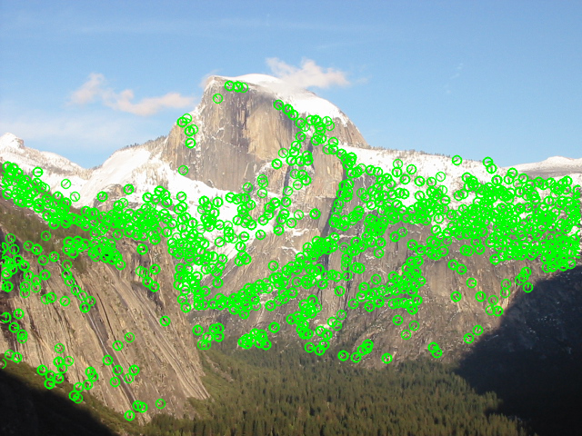

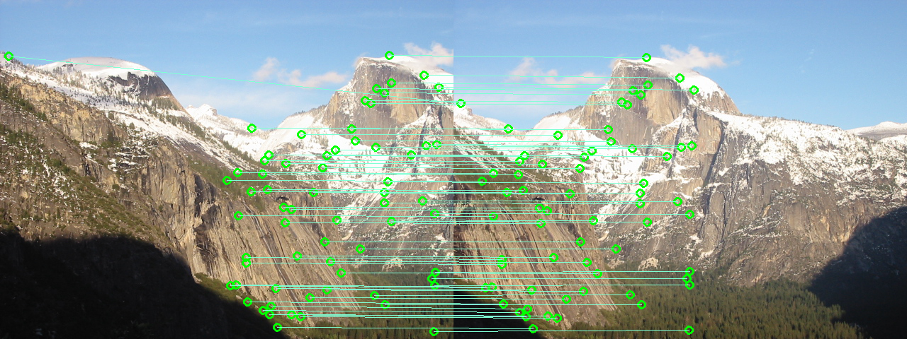

1. 1063 matches were found on my own pictures.

For MOPS + Ratio distance. Here’s feature match. The overall performance is quite good with only 1 outlier out of 1063.

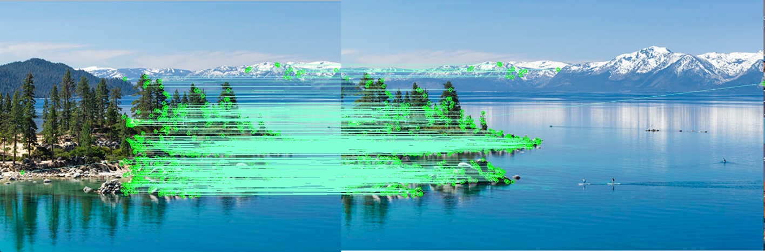

1. The Harris Corner Detector provides large number of interest points that has some local non-maximum suppression. But we want the points to be spatially diverse. **Adaptive Non-Maximal Suppression algorithm** is used to get feature points which are evenly distributed throughout the image. To perform adaptive non-maximal suppression for each interest point we compare the corner strength to all other interest points and we keep track of the minimum distance to a larger magnitude interest point. This works by computing the suppression radius for each feature, which means the smallest distance to another point is strongest. After we've computed this minimum radius for each point, we sort the list of interest points by descending radius and take the top N. We get the *n* most dominant in their region as output, which ensures we get spatially distributed strong points.

**Extra Credit:**

AUC = 0.937

Average distance = 286

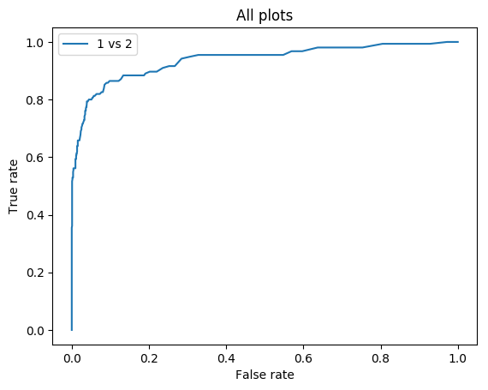

The first change to the extracredit file is that a Canny edge detector was used. This edge detector was thresholded by 33% of the image's median value. The images were preprocessed using this edge detector. This therefore detected more Harris Key points for blurrier images. Additionally, some other small tweaks were made to the existing algorithms that improved the accuracy. This included increasing the window size for computing the local maxima, increasing sigma for the gaussian filter in the MOPS algorithm, using a larger window size for MOPS, and scaling down by less for MOPS.  
  
These changes increased the AUC for yosemite from about 90% to about 92%. For the blurrier expample (the bikes images), the AUC increased from 33% to 90%. The reasoning for this is that the blurrier bike images now have more detectable harris points.  
  
When running this extracredit.py file, use the custom descriptor type. The custom algorithm is what modifies the MOPS values. The Harris detector has been modified to make the other changes, so leave the Keypoint Type as Harris. All the other values also remain the same.